**VALLEY VIEW UNIVERSITY**



**GROUP 10**

**SPORTS EVENTS MANAGEMENT SYSTEM**

**NAME ID**

**OBENG, EMMANUEL 215CS01003146**

**HELOO, JULIA AMI 216BE02004217**

**BRIGOL BILL, CLAVEL 215IT01003200**

**SINTIM BERNARD 215CS01002791**

**ADJEI, RICHARD 215CS01002558**

# **CHAPTER ONE**

## **INTRODUCTION**

## **1.1 PURPOSE**

The purpose of this document is to present a detailed description of the Sports Events Management System. It will explain the purpose and features of the system, what the interfaces of the system will do and what they represent, the constraints under which the system will operate and how the system will react to external stimuli.

## **1.2 SCOPE**

The Sports Events Management System is a Web-based Application which will help Students enroll for trending and interesting sporting activities in their Organizations and Institutions. Also will help advertise events and provide all informations about the event which will be guide for the user of the system and also help evaluate Student’s Participation in events.

## **1.3. OVERVIEW**

This part of the document gives a general view which includes the deliverable hardware, categories of users of the System and the functional and data requirement of the deliverable. A general and in-depth description of the System is highlighted more in section (2. Overall description) with the next section (3. Specific Requirement) giving the functional requirement, data requirements and constraints. Also giving the specific requirement of the deliverable, with supporting information.

# **CHAPTER TWO**

## **2.0. OVERALL DESCRIPTION**

The section of this document talks about how the system will manage to eradicate this problem. It contains also the User requirement from the Sports Director of the University and other key members in the Sporting department on how the system should be built. That is an In-depth discussion of the major features of the system.

The specifications below show a detailed description from the Sporting sector and provides detailed product functions.

## **2.1. Project Perspective**

The project will run on any University environment and Institution.

Database System

Sports Events Management System

## **2.2 Project Functions**

### **2.2.1 The system will have the following functions**

Event Supervisor

Student/Participants

Administrator

## **User Characteristics**

The user is expected to be an Internet literate. Once he/she can log in to the system and navigate between web pages, he /she can use the basic functionalities of the system.

## **2.3 Constraints**

The system must run on any windows operating system environment. The system shall use SQL server management studio 2008 database for all data management tasks.

# **CHAPTER THREE**

## **3.0 System Requirements**

**3.1** **Functionality:**

**Introduction-**This part of the document contains the requirement for the Sports Events Management System which gives a detailed description of the product(deliverable) and all its features.

* + 1. **Multiple User authentication and Platform**
    2. The system shall provide User sign-in configurations to new Users of the system.
    3. The system shall perform User authentication and validation at the Login stage.
    4. The system shall allow the user to reset a password once forgotten by the user.
    5. The system would not redirect the user to its specific platform unless all configuration data is filled correctly and no portion is left null.
    6. The system shall notify the User when a configuration step is skipped or not filled properly so as the filter and accept only accurate details.
    7. The system shall direct the user to the specific platform based on the user type from the configuration details of the user
    8. **Provides awareness on Trending events**
    9. The system shall provide an interactive and responsive interface on this platform to make participation interesting.
    10. The system shall provide detailed information of trending and ongoing events.
    11. The system shall give the user the option to either view comprehensive details of the event of his choice.
    12. The system shall give the user the option to enroll for a particular event.
    13. The system shall give the user whom will not enroll for any event the chance to view results of events.
    14. **Accurate Events Sorting**
    15. The system shall categorize the events in terms of indoor and outdoor.
    16. The system shall provide corresponding events to the category of event chosen.
    17. **Provides Effective Events Supervision**
    18. The system shall appoint an events supervisor to each and every event.
    19. The system shall have all records on participants enrolled in all events.
    20. The system shall have all scores of events keyed in the by event supervisor.
    21. **Provide error correction Platform**
    22. The system shall allow the administrator to check and correct all inaccurate information once uploaded unto the system.
  1. **Usability**

**Graphical User Interface**

The system shall be easy to navigate through the all the web pages.

The system shall provide a Highly User friendly interface, responsive and attractive web forms.

The system shall provide high definition images as part of the description for each event.

The system shall have a sporting nature and an entertaining and intriguing environment to depict its nature.

* 1. **Accessibility**

The system shall be available for at least more than 10 hours a day.

The system should be made accessible anywhere regardless of the geographical location of an authorized user.

* 1. **Reliability & Availability**

The system shall provide a reliable database for quick and fast querying.

* 1. **Performance**

The system shall be Wed Based and has to be run from a web browser.

The performance also depends on the hardware component of the User.

The system should be available for user in real time and always up to date.

The performance of the system shall be fast and efficient in searching, editing, deleting and updating, and generation of reports.

* 1. **Security (Data Transfer)**

The system shall use validations in all User configurations and details.

The system shall automatically log out all customers after a period of inactivity.

The system shall confirm all information and details with the Users web browser.

The system shall not leave any trace of the Users details on the device containing the user’s password.

The system shall not leave any loop hole on the Users device containing any of the user’s confidential information.

* 1. **Data Storage**

The system’s back-end server shall never display a User’s password**.**

The system shall filter all data properly before entering into the database.

The system should be able to store only the useful data, and data that will used later on.

* 1. **Error Handling**

The system should be able to handle unexpected errors quickly and easily by alerting users for easy and early detection and rectification.

* 1. **Design Constraints**
     1. **Web Based Product**

There are memory requirements

The Users device must be equipped with web browsers such as Internet explorer, Google chrome or Mozilla Firefox.

The deliverable must be stored in such a way that allows the Users easy access to it.

Response time for loading the system should take no longer than 10 minutes.

TheUser should have a general knowledge of basic computer skills required to use the system.

* 1. **Software Requirements**

Microsoft SQL Server 2012

Visual Studio 2015

* 1. **Interfaces**

There are many interfaces supporting the running of the system such as the User interface, Software Interface and Hardware Interface.

* + 1. **User Interfaces**

The user interface for the software shall be compatible to any browser such as Internet Explorer, Mozilla or Google Chrome by which user can access to the system.

The user interface shall be implemented using tools such as Java script, Bootstrap Css, HTML5.

* + 1. **Hardware Interfaces**

Since it is a web based application it must run over the internet, all the hardware shall require to be able to connect to the internet as the hardware interface for the system. As for e.g. Modem, WAN – LAN, Ethernet Cross-Cable.

* + 1. **Software Interface**

The system shall communicate with the database for easy querying.

The system shall communicate with the database for identification if authorized and registered users.

The system shall communicate with the events supervisors for Event results.

* + 1. **Communications Interface**

The system shall use the HTTP protocol for communication over the internet and intranet communication will be through TCP/IP protocol suite.

* 1. **Licensing Requirements**

Not Applicable

* 1. **Legal, Copyright and other notices**

The Sports Events Management System should display the copyright, word mark, trademark of the Institution and other Sporting organizations.

* 1. **Applicable Standards**

The system shall be per Users definition and standard.

* 1. **Supporting Information**

**Please Refer to the following documents.**

1. SRSExample-webapp.doc
2. SRS4.0.doc
3. srs_example_2010_group2.pdf
4. SWEBOKv3.pdf
5. Somerville - Software Engineering 9ed.pdf

# **CHAPTER FOUR**

## **4.0 Diagrams**

### **4.1 UML DIAGRAM**



### **4.2 USECASE DIAGRAM**

### **4.3 ACTIVITY DIAGRAM**



# **CHAPTER FIVE**

## 5.0 DATA DICTIONARY

### 5.1 DATA DICTIONARY: Event Table

|  |  |  |
| --- | --- | --- |
| Field Name | Data Type | Primary Key |
| EventId | varchar(50) | Yes |
| Event_Venue | varchar(50) | No |
| Event_Date | varchar(50) | No |
| SupervisorID | varchar(50) | No |
| Description | varchar(MAX) | No |
| image | image | No |

### 5.2 DATA DICTIONARY: EventType Table

|  |  |  |
| --- | --- | --- |
| Field Name | Data Type | Primary Key |
| EID | int | Yes |
| EventType | varchar(50) | No |
| Event | varchar(50) | No |

### 5.3 DATA DICTIONARY: LOGIN TABLE

|  |  |  |
| --- | --- | --- |
| Field Name | Data Type | Primary Key |
| loginID | int | Yes |
| Username | varchar(50) | No |
| Password | varchar(50) | No |
| Name | varchar(50) | No |
| Email | varchar(50) | No |
| Usertype | Nchar(10) | No |

### 5.4 DATA DICTIONARY: Participant TABLE

|  |  |  |
| --- | --- | --- |
| Field Name | Data Type | Primary Key |
| ParticipantID | int | Yes |
| Eventname | varchar(50) | No |
| EventType | varchar(50) | No |
| Event | varchar(50) | No |
| Name | varchar(50) | No |
| phone | int | No |
| Gender | Varchar(50) | No |

### 5.5 DATA DICTIONARY: Records TABLE

|  |  |  |
| --- | --- | --- |
| Field Name | Data Type | Primary Key |
| RecordsID | int | Yes |
| Eventname | varchar(50) | No |
| EventType | varchar(50) | No |
| Event | varchar(50) | No |
| TeamA | varchar(50) | No |
| TeamB | Varchar(50) | No |
| ScoreA | int | No |
| ScoreB | int | No |
| Date | date | No |

### 5.6 DATA DICTIONARY: Supervisors TABLE

|  |  |  |
| --- | --- | --- |
| Field Name | Data Type | Primary Key |
| SupervisorID | int | Yes |
| SupervisorName | varchar(50) | No |
| ContactNo | varchar(50) | No |

**CHAPTER SIX**

This section presents and initial storyboard for the proposed system. Each page was designed to provide the functions of the system. The first iteration is based on the system structure layout.



# **CHAPTER SEVEN**

## **7.0 USER MANUAL**

Click here to signup if you don’t have an account yet

## **7.1 HOME PAGE**

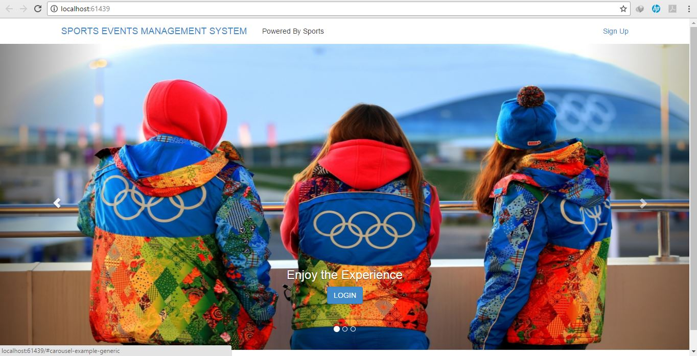

This is the Button you click if you have already Signed Up on the System.

The Picture above shows the overview of the Home Page which displays a series of pictures which pertains to the environment or category the system belongs to.

## **7.2 Sign Up Page**

Click on this Button after you have Signed Up

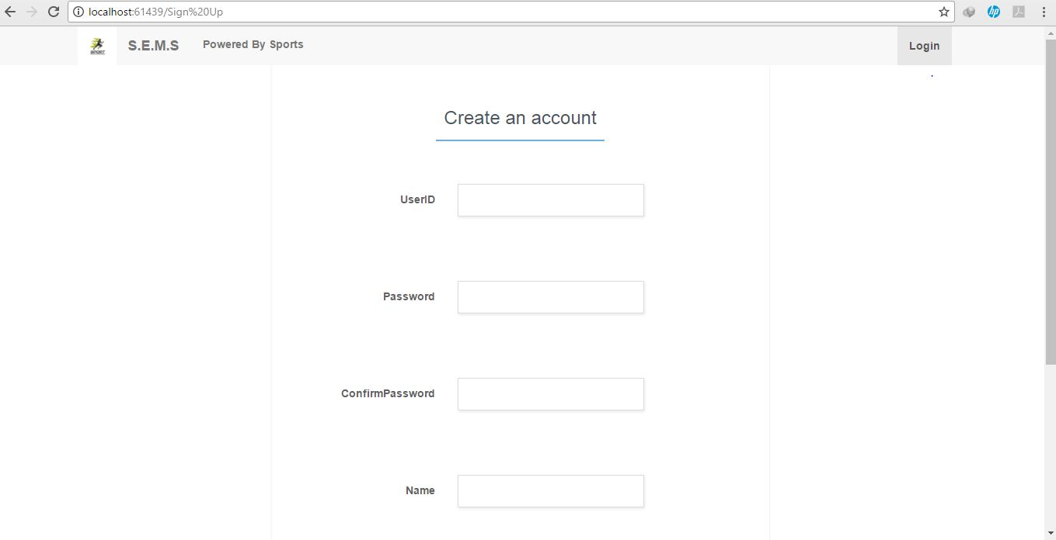

The Picture above shows the overview of the Signup Page which displays enables the user to Sign up on the System for the System to recognize the User Type.

## **7.2 Login Page**

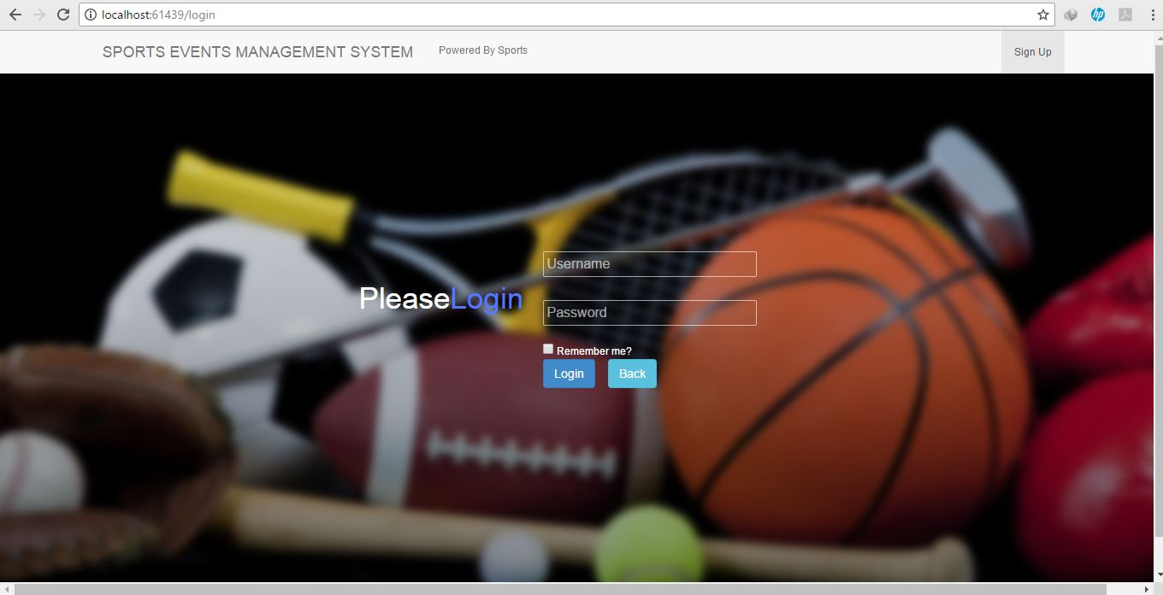

Click here to Login and return page to the homepage

The Picture above shows the overview of the Login Page which Logs the Users to their Particular Page.

## **7.3 Trending Events Page** (Participants/Student)

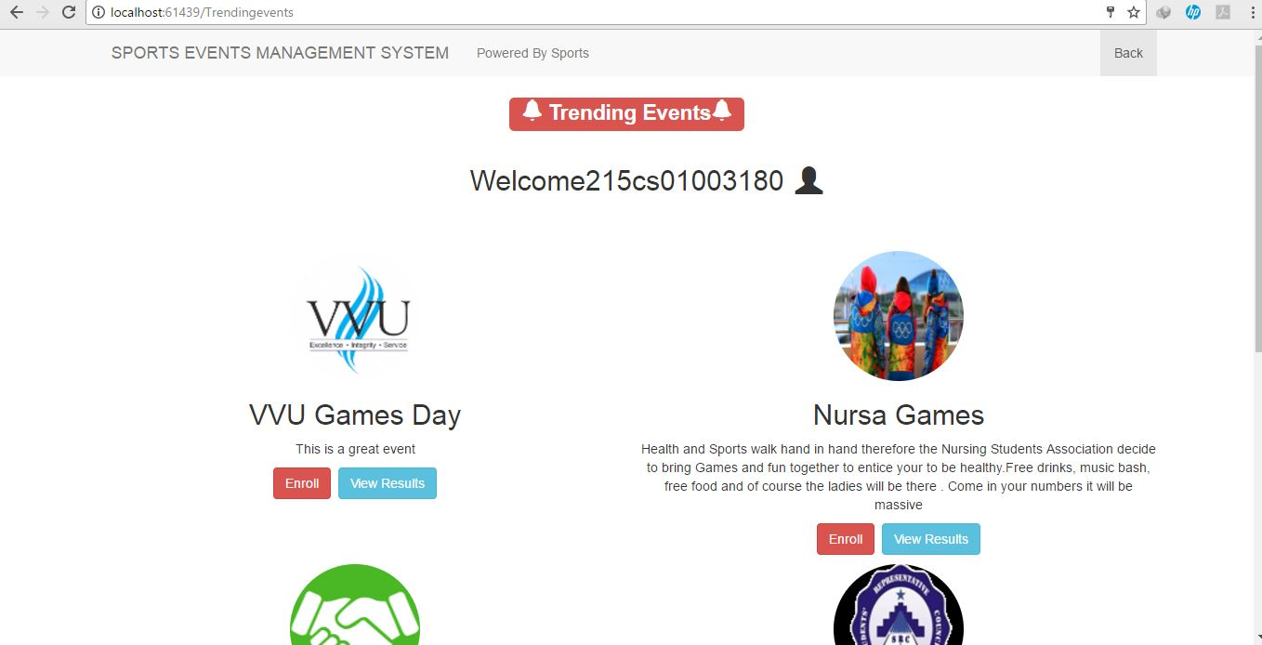

Click Here to View Results

Click Here to Enroll

The Picture above shows the overview of the Trending Events Page which shows the User a list of events with their descriptions.

## **7.4 Participant Enrollment Page** (Participants)

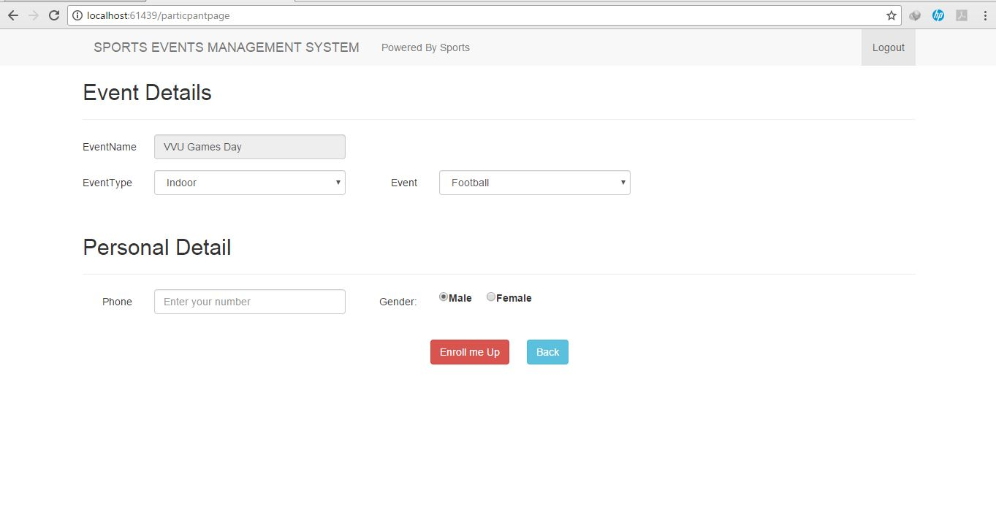

Click Here to Enroll for an Event

The Picture above shows the overview of the Enrollment Page where the User fills in his participation details.

## **7.5 View Results Page** (Participants/Students)

Click Here to Log Out

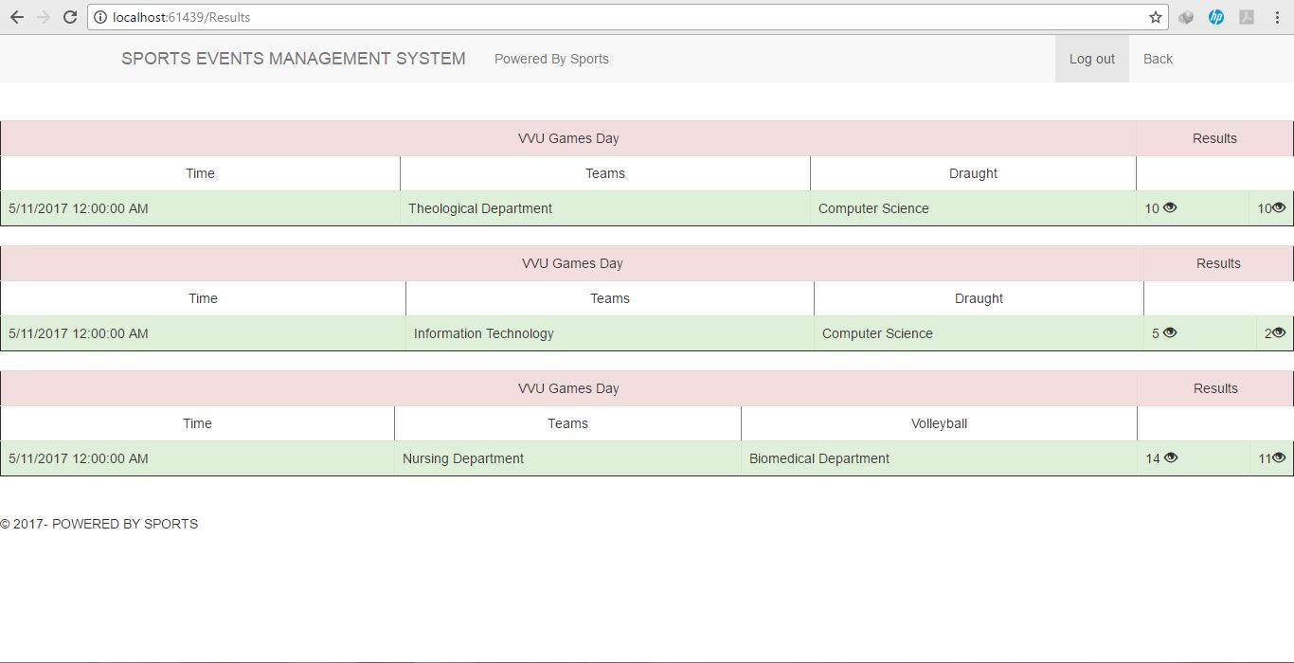

The Picture above shows the overview of the View Results Page where Scores and results of the Events can be viewed.

## **7.6 Supervisor Page**

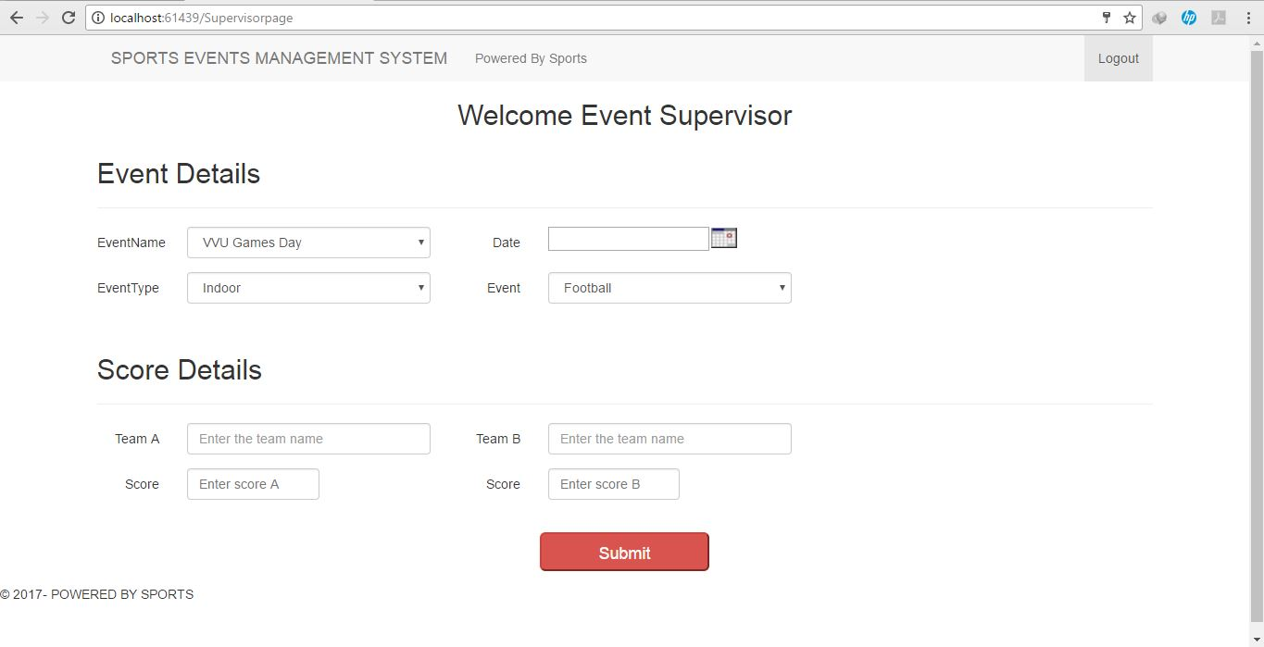

Click Here to Submit Results

The Picture above shows the overview of the Event Supervisor Page where the Names of the Teams are entered and Scores of the outcome of the Events Are Submitted.

## **7.7 Administrator Page**

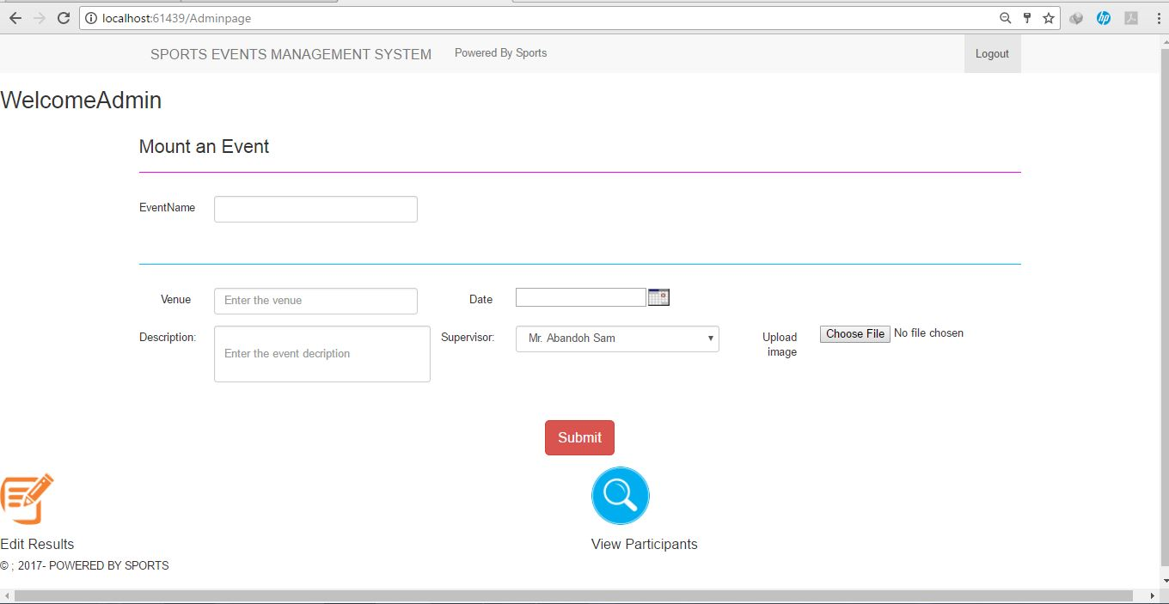

Click Here to make correction to results submitted if there be any error

Click Here to View Participants who enrolled for particular events

Click Here to Mount an Event after details of the Event have been filled

The Picture above shows the overview of the Administrator page and its functions where he mounts the Events, Edits Results, View Participants and lastly downloads and views Reports.

## **7.8 Edit Results Page** (Administrator Page)

Click on the Search Button

Select your Event from the Dropdown List

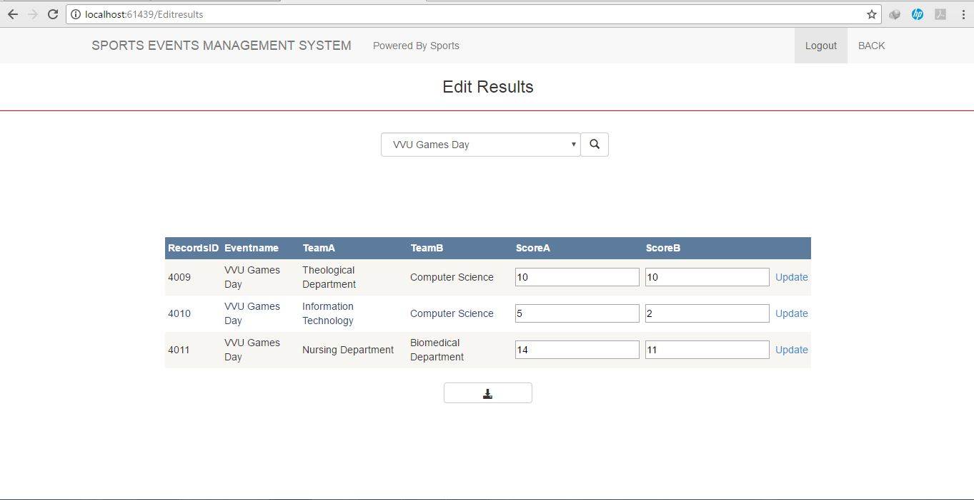

Click on Update Button to update and Modify Results

Edit Results by replacing correct one

Click to View and Download Report

Click on the search button

## **7.9 View Participant Page** (Administrator Page)

Firstly, chose an Event form the dropdown list

Chose from the Radio Button Option

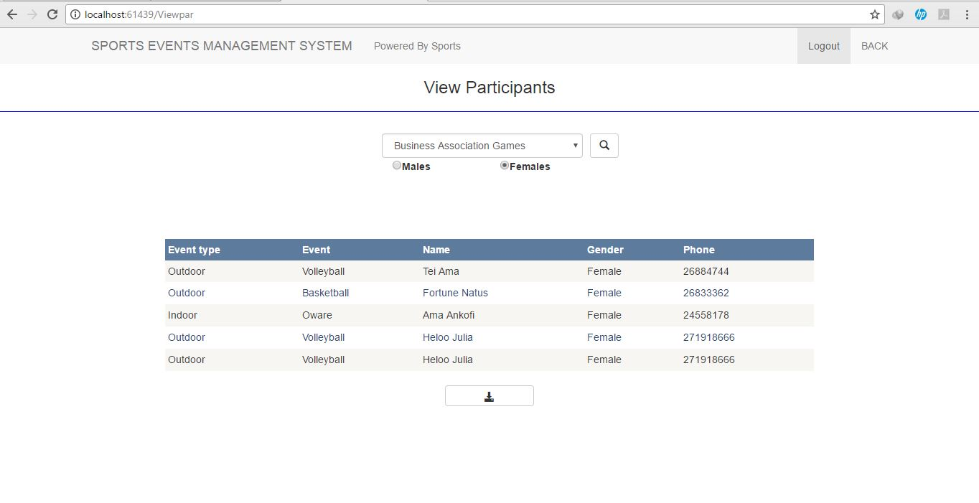

Click to View and Download Report